**Notice is given under S115 of the Environment Act 2021 and 96A of the Highways Act 1980 that these street trees are considered for removal.**

**Following a professional inspection from the Arboricultural team, the tree located at: the side of 51 Tennyson Road.**

### **Has been identified for removal **to prevent or alleviate damage to property or the Highway.****

To comment on this consultation please visit [www.essexhighways.org/street-tree-consultations](http://www.essexhighways.org/street-tree-consultations) or scan the QR code below.

This consultation is known as MAL20591/2.

After 28 days, the consultation will close, and a decision will be published online.

Date of Notice: Monday, 02 December 2024.

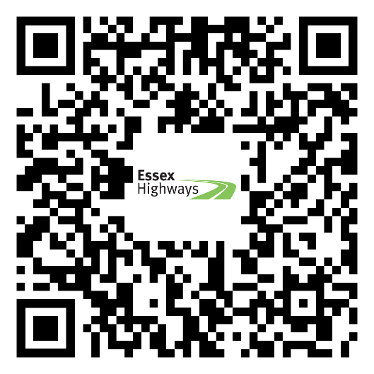

The Arboricultural Team at Essex County Council.